Grand Canyon National Park

Teacher-Led Ecology Lessons and Worksheet

*This teacher-led ecology lesson is intended to help your students better engage with the plants and wildlife around them. This program is designed such that the stations can be completed in any order; we recommend splitting your group into smaller pods and having each pod spread out along the Rim Trail to avoid crowding. The final two pages of this document are the worksheet for students.*

**Essential Question:** How can I observe and notice evidence of adaptations and relationships in challenging environments?

**Grades:** 3rd, 4th, 6th

**Arizona Science Standards:** 3.L1U1.5, 3.L2U1.6, 3.L2U1.8, 4.L4U1.11, 6.L2U1.13, 6.L2U1.14

**Materials:** For each student, supply one double-sided worksheet, a pencil, and a surface to write against.

**Location:** Bus parking is available near the Visitor Center, at Park Headquarters, or at the Backcountry Office. There is no bus access to the Yavapai Geology Museum parking area. The program takes place on the Rim Trail between the Village and the Visitor Center. Full South Rim map: [Grand Canyon Pocket Map: South Rim Services Guide (nps.gov)](https://www.nps.gov/grca/learn/news/upload/sr-pocket-map.pdf)

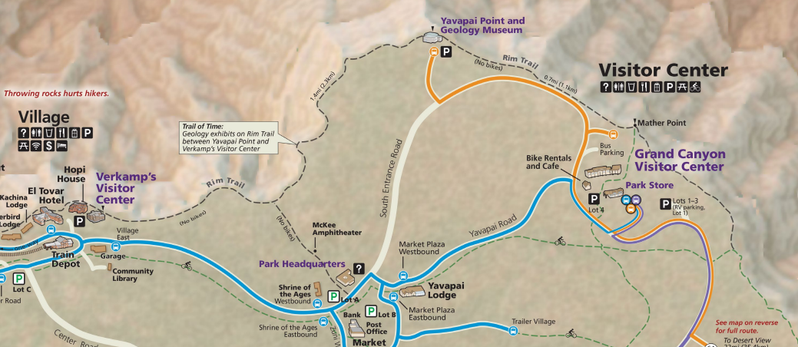

**Station 1: Engage and Explore**

Have students observe a desert plant (yucca, cactus, etc.) and ask them the following questions:

**What do you see? What colors, patterns, shapes and other features? What do you wonder about? What does it remind you of?**

Have students observe a forest plant (shrub, tree, etc.) and answer the same questions:

**What do you see? What colors, patterns, shapes and other features? What do you wonder about? What does it remind you of?**

**Station 2: Create a Plant Identification Guide**

Have students find several plants and describe it using this plant guide example (also included on their worksheet):

|  |  |  |  |  |
| --- | --- | --- | --- | --- |
| Drawing | Description | Color | Texture/Pattern | Height |
| Drawing of a small tree | Tight curled needles, twisty bark, tree | Grey/tan  bark, light green needles | Scraggily, rough and looks like bark is pulling away from tree | Twice as tall as me |

Have students use the attached sheet to make their own Plant Identification Guide, following the format above. Have them do this for 2-5 plants, depending on time available. Then have them switch guides with another student and see if they can locate the plant their partner draw and described.

**Station 3: Mountain Lions and Bighorn Sheep**

Find an open area where students can have space to move off the trail. This game is similar to Sharks and Minnows, if students are familiar with that game.

* Choose two or three students to be mountain lions and the other students to be bighorn sheep. All the bighorn sheep start in a line on one side which is their “home”. The bighorn sheep are safe at their “home” and cannot be tagged.
* They need to try to the get the other side, which is “the water source”.
* *Give them a limited time, one or two minutes, to get from one side to the other.*
* If they are tagged by a mountain lion, they freeze in place and become a rocky cliff, which provides a “safe zone” for the other bighorn.
* If a bighorn sheep is touching someone who is a rocky cliff, they are safe from the mountain lions.
* The bighorn sheep that get past the mountain lions and make it to the water source are still in the game. The bighorn sheep are safe at the water source and cannot be tagged
* Next, the bighorn sheep try to get back home without being tagged by a mountain lion, using the students who are rocky cliffs as safe zones during their return home.
* Again, give the bighorn a limited time to get back to their home.
* This back and forth continues until only one bighorn sheep is left, the winner of the game.
* If you have time, that winner then becomes the mountain lion in the next round.

If students have energy and concentration, have a brief discussion on predator prey and food chains.

**Station 4: Journaling and Reflection**

Station 4 is flexible; some students may need time to just sit and enjoy the canyon. Other students may want something more structured. This is up to the teacher to decide what they feel their students need.

Students will 15-20 minutes to either draw, write a story, write a poem, etc. for the following prompt:

**If you were a plant living on the edge of Grand Canyon, what would you see, feel, and hear?**

**Name:**

**Plant Guide**

As you walk along the path, locate plants and draw and describe them in this plant guide. Draw at least two.

|  |  |  |  |  |
| --- | --- | --- | --- | --- |
| Drawing | Description | Color | Texture/Pattern | Height |
| Drawing of a small tree | Tight curled needles, windy bark, tree | Grey/tan bark, light green needles | Scraggily, rough and looks like bark is pulling away from tree | Twice as tall as me |
|  |  |  |  |  |
|  |  |  |  |  |
|  |  |  |  |  |
|  |  |  |  |  |

**Journaling**

Draw, write a story, write a poem, etc. for the following prompt:

**If you were a plant living on the edge of Grand Canyon, what would you see, feel, and hear?**